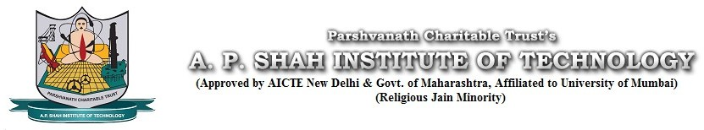

**Department Of Computer Engineering**

SEM III & IV: WEEK – 11 Academic Year: 2021 to 2022

Date: From 06-12-2021 to 10-12-2021

|  |  |
| --- | --- |
| **Progress Planned** | **Progress Achieved** |
| Learn Java language. | PPT and Report of our app is created. |
|  | Learning Java language. |
|  |  |
|  |  |
|  |  |
|  |  |
|  |  |
|  |  |
|  |  |

Guides Review:

Signature

Team Member 1: ABHAY SHARMA

Team Member 2: SAHIL SAJWAN

Team Member 3: ASHNEEL RAJE

Team Member 4: SAMRADNYEE SHINDE

Project guide: **SHAFAQUE FATMA SYED**

Signature:

Date:

Project coordinator: